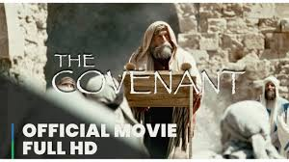

Welcome to GCSE Religious Studies! J We will be studying GCSE Judaism and GCSE Christianity. Your summer project is to watch the film <<The Covenant>> (The Covenant | English | Official Full HD Movie - YouTube)
... and answer the questions in the pack. This will be a super reference and resource for the next two years and will go in the front of your folders, where you can always refer back to it.
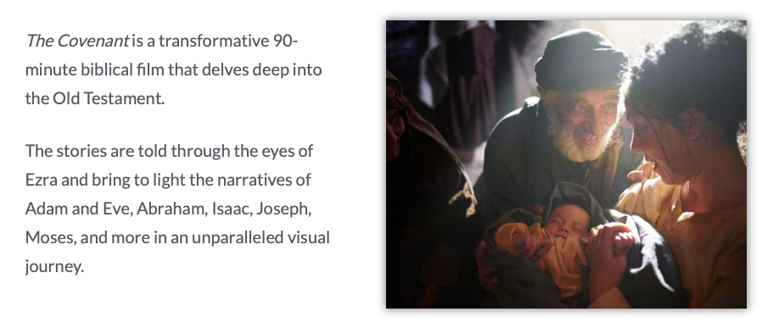

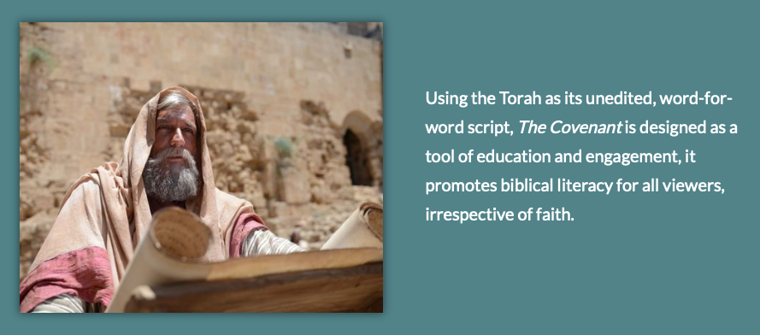

Summer Project – Religious Studies
GCSE Judaism
The Covenant – questions to answer whilst watching

Covenant means the special relationship between God and the Jewish people

The film starts with Ezra, a Jewish priest (440 BC) and a teacher of the Law (The Ten Commandments) who remembers the History of the Jewish people as the chosen people of God. He speaks to a crowd of Jews who are waiting to hear the readings.

Ezrah begins by reading the book of Genesis which you will already be familiar with!

THE FILM IS SPLIT INTO CHAPTERS ON THE YOUTUBE BAR – after each chapter answer the questions J

https://www.youtube.com/watch?app=desktop&v=N3iuqxI5Fw8

The Garden of Eden
- How is a human being formed?

- What was the command of God in the Garden of Eden?

- What was not good for the man?

- What did they know after the snakes deceipt?

The Great Flood
- Because of the wickedness and evil of the human race after Adam and Eve what does God do?

- How do Noah and his family survive?

- What was the promise God made in his Covenant with Noah?

God’s Promise to Abraham (2000 BC)
- What does God say to Abraham? Where does he tell him to go

- What is the promise God makes to Abraham? What does it mean to say that his descendants will be like the <<stars of heaven>?

- What was the name of the child Abraham had with the slave Hagar? What was the name of the child Abraham had with his wife Sarah?

God tests Abraham

- How did God test Abraham? What did he ask him to do with his son Isaac?

- What did Abraham say that God would provide? What did this show about Abraham’s trust in God?

- What did the angel do at the last moment and what did the angel tell him after?

- What does God say Isaac’s son Jacob will be called? Does this name sound familiar to you?!

The Story of Joseph (son of Jacob)

- Why are Joseph’s brothers jealous?

- What do Joseph’s brothers do to him?

- What skill or gift does Joseph have?

- What does Joseph become and what is the dramatic finale of the story?

The Story of Moses (1391–1271 BC)

- How did the Jews become slaves of the Egyptians?

- Why did the new Pharaoh want to murder the Jewish children?

- What happened to the baby Moses?

- Why did Moses flee?

- Who was in the Burning Bush and what did He say? What did he say His name was?

- What was Moses sent to do?

God sends the plagues to Egypt

- What were the Ten Plagues?

- Why did God send the Ten Plagues against the Egyptians?

The Passover

- What did the Jews have to put on the doorposts of their houses?

- What did they eat on that night?

- What happened at midnight? What does <<Passover>> refer to?

The Israelites are released

- Why were they released?

- Who was in the Pillar of Fire and the Cloud?

Moses splits the Red Sea

- When Pharoah realised the mistake he had made what did he do?

- Why did the Jews at this point turn against Moses?

- What did Moses do to save them and what happened to the Egyptians?

The Israelites Wander the Desert

- How did the Israelites grumble against Moses in the desert? How did Moses reply?

- What did God send to the Israelites to stop their grumbling?

- Why did God ask Moses to strike the rock?

God gives Moses the Ten Commandments

- What could be heard and seen on Mount Sinai before Moses went up the mountain?

- What were two examples of the Commandments?

- What the tablets made of and who inscribed on them?

- Whilst Moses was up Mount Sinai what did the Jews do that caused him to become angry?

The Tabernacle is built

- What did God say the Covenant with Moses would be like?

- What is a tabernacle? What things was it made of and what was put in it?

The Israelites wander the desert for 40 years

- Why did the Jews grumble again against Moses? What did Moses ask God to do to them?
- Complete this sentence that Moses teaches, <<HERE O ISRAEL…>>

Moses is taken by God

- What are Moses’ parting words?

